# Introduction

Android updated storage access for Android 11 (API Level 30) [1, 3]. This document shows how the storage access was implemented for the AccelPlot application.

# Discussion

Discovered most apps don’t need broad access; left behind files that filled up drive. Scope storage introduced in Android 10 (API Level 29).

Principles:

* Better attribution. Helps remove content
* Protecting app data. Internal app directories private. SD directories need to be protected from other apps.
* Protecting user data.
* Unrestricted access to your own app storage. You can write to your own directory.

An app always has unrestricted access to their own storage, both external and internal [4, 5].

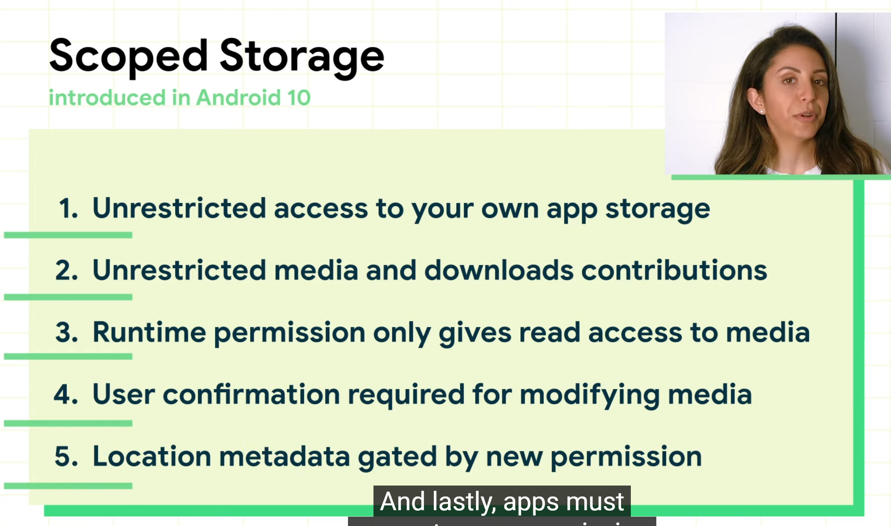

Figure - Scoped storage notes [2].

requestLegacyExternalStorage lets users opt out since scoped storage did not initially satisfy all of the use cases

# References

1. <https://developer.android.com/about/versions/11/privacy/storage>
2. <https://stackoverflow.com/questions/64221188/write-external-storage-when-targeting-android-10>
3. “Preparing for scoped storage (Android Dev Summit ’19).” Oct 24, 2019. <https://www.youtube.com/watch?v=UnJ3amzJM94>.
4. “Storage access with Android 11.” Jun 10, 2020. <https://www.youtube.com/watch?v=RjyYCUW-9tY>.

Explains the rationale behind some of the odd behaviors between Android 10 and 11

1. “Scoped Storage in Android in a Nutshell.” Dec 17, 2020. <https://www.youtube.com/watch?v=TkOzcyzH1hU>.

Good visualization of storage model in Android. Confirms thoughts about private app storage.